CSA1519-CLOUD COMPUTING LAB EXERCISES
Jayaharini.J(192371034)
EXP – 3 : Car Booking System
Aim
To create a simple Car Booking System using Zoho Creator, a cloud-based SaaS platform, for managing car bookings, customer details, travel information, and fare calculation.
Procedure
- Log in to Zoho Creator.
- Create a new application named Car Booking System.
- Create a form named Car Booking.
- Add fields such as Customer Name, Pickup Location, Drop Location, Distance (KM), Rate per KM, Number of Toll Gates, Toll Charge, and Total Amount.
- Create a workflow to calculate the Total Amount based on the distance traveled and toll charges.
- Create reports to display all car bookings and payment details.
- Save and publish the application.
- Test the application by entering sample booking details and verify that the total amount is calculated correctly.

Output :
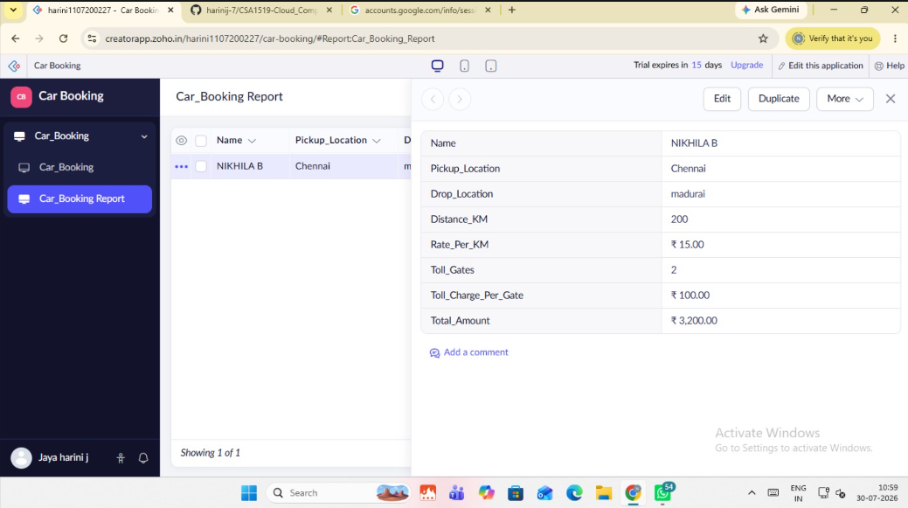
Result
The Car Booking System was successfully created using Zoho Creator, enabling users to book cars, calculate travel charges based on distance and toll gates, and manage booking details through a cloud-based SaaS application.

